**Ordering and Delivery Tracker App for Quadro King Water Station Retail Store**

**A Capstone Project Presented to the Faculty of the**

**College of Computer Studies**

**AMA Computer College – Las Piñas Campus**

**In Partial Fulfillment for the Requirements of the Degree of**

**Bachelor of Science in Information Technology (BSIT)**

**Marlo, Dael**

**Alegrid, Floren Joseph A.**

**Belbis, Luis Gabriel O.**

**February 2021**

**ACKNOWLEDGEMENT**

The authors would like to express their profound and sincerest gratitude to the following individuals who helped in successfully accomplishing this study:

First and foremost, to **Prof. Karren de Lara** the group’s academic adviser, for the time, patience, support and guidance to the researchers despite the busy schedule and never failing to accommodate and guide them all throughout the study.

To the researchers’ parents for providing them unfailing support and continuous encouragement throughout the months of the study and through the process of researching and writing this study. For serving as an inspiration and became the fuel to keep the researchers from moving forward.

**The Researchers**

**ABSTRACT**

Online Shopping advancements have been so drastic that it has evolved to be a part of our life. Today customer doesn’t need to drive to some shop foy buying products but they prefer to check it over the internet for price, offers, reviews and order online. In most of the Metro Manila, water containers are purchased from shops for they needs. The current working system procedure in the city where customer needs to call/drives down to the shop to order water container by providing the shopkeeper a deliverable address and then a delivery person delivers the order to customers door step, as this system works totally offline and has lot of disadvantages. The major drawbacks in the current offline system are repeated calls from and to customer, if multiple orders are placed from same area the delivery person travels multiple times, there is no order tracker, etc. This paper proposes and android application for water container ordering and delivery tracker system, where customer can order over an android application by searching the nearby shops which provide the service and make payment through cash on delivery. This proposed system helps in overcoming the disadvantages of the current offline system. This application provides assistance module to the customer, store owner, and delivery person (Rider). It moderately helps in developing digitally empowered society as we are now.

**DEFINITION OF TERMS**

The following are the definition of terms that are used by the proponents for the research.

Android - is a mobile operating system that was developed by Google to be primarily used for touchscreen devices, cell phones, and tablets.

App - an application, especially as downloaded by a user to a mobile device.

Database - a structured set of data held in a computer, especially one that is accessible in various ways.

E- Commerce - commercial transactions conducted electronically on the internet.

Framework - a basic structure underlying a system, concept, or text.

Google Firebase - a Google-backed application development software that enables developers to develop iOS, Android and Web apps.

Global Positioning System (GPS) - An accurate worldwide navigational and surveying facility based on the reception of signals from an array of orbiting satellites.

Graphical User Interface (GUI) - is pronounced "gooey." It is a user interface that includes graphical elements, such as windows, icons and buttons.

Hardware - the machines, wiring, and other physical components of a computer or other electronic system.

Online System - are online versions of information systems, which is “the process of and tools for storing, managing, using, and gathering of data and communications in an organization.

Software - the programs and other operating information used by a computer.

**TABLE OF CONTENTS**

Title Page

Approval Sheet

Acknowledgements

Abstract

List of tables

List of Figures

List of Appendices

List of abbreviations and symbols

Definition of terms

**Chapter 1: PROJECT AND ITS BACKGROUND**

Project Context……………………………………………………..…………………1-5

Purpose and Description…………………..…………………………………………5-7

Objective of the study……………………………………………………………………7

Significance of the study……………………………………………………………...8-9

Scope and limitation…………………………………………………………………9-11

**CHAPTER II: Related Literature**

Foreign Literature…………………………………………………………………..12-17

Local Literature……………………………………………………………………..17-23

Foreign Studies…………………………………………………………………….24-26

Local Studies……………………………………………………………………….26-29

Synthesis……………………………………………………………………………29-32

Technical Background……………………………………………………………..32-33

**CHAPTER III: METHODOLOGY RESULTS AND DISCUSSIONS**

Software Design, Products, and/or Processes………………………………….34-36

System Architecture………………………………………………………………..36-38

Conceptual Design…………………………………………………………………39-43

Cost Benefit Analysis………………………………………………………………43-46

Requirement Analysis……………………………………………………………..46-49

System Architecture / System Flow………………………………………………49-62

Block Diagrams

Development and Testing

Input and Output Reports Analysis

Description of Prototype

Implementation Plan

Implementation Results

**DISCLAIMER**

The study has been made the product of hard work of the researchers. It has been approved and accepted by the panel of reviewers. Hence, no part of this paper maybe used without proper citation or approval from the authors.

**List of Tables**

Table 1 – Hardware Cost (Rider)

Table 2 – Hardware Cost (Admin)

Table 3 – Software Development Cost

Table 4 – System Cost

Table 5 – Utility Expense

Table 6 – Training Cost

Table 7 – Summary Cost

**List of Figures**

Figure 1 - HIPO of the App

Figure 2 - Customers Home Page

Figure 3 - System Architecture of the System (1)

Figure 4 - System Architecture of the System (2)

Figure 5 - Conceptual Design

Figure 6 - V-Model

Figure 7 - Current Water Ordering System

Figure 8 - Dataflow Diagram of the proposed System

Figure 9 - Customer Sign Up

Figure 10 - Customer Profile

Figure 11 - Water Station Search Bar

Figure 12 - Order Button

Figure 13 - Order Menu

Figure 14 - Order Status

Figure 15 - Recent Orders

Figure 16 - Driver App Flow

Figure 17 - Rider Sign Up

Figure 18 - Rider App Services

Figure 19 - Rider's Job Orders

Figure 20 - Store Owner Registration

Figure 21 - Store Owner Sign In

**Chapter 1**

**PROJECT AND ITS BACKGROUND**

Nowadays, people lean on online deliveries for their essential needs like food, groceries, and etc. The Ordering and Delivery Tracker App will innovate the services of water delivery businesses and also their management of it. The goal of the researchers is to make an application that will help the management of the orders, and to track the delivery riders, also to track the address of the customers using Global Positioning System (GPS).

**Project Context**

Quadro King Water Station is located in Las Pinas, Pilar Village. The business provides clean drinking water to the residents of Pilar Village, as well in TS Cruz Village, and Almanza Uno. The business started in 2014. Their products only consist of 2 types of gallons, one is the round gallon, and the other is the rectangular shaped gallon with a faucet. Mostly people call the water station to place their orders and they tell their address through the phone or via text message, but there are also people who places the order when they visit the water station. They cater around 100-200 gallons a day. We the proponents want to create an application that will innovate and help the workers have a more easy way of transacting with customers , and tracking of their sales.

An online system will always ensure that a role is/are carried out to achieve a precise outcome. Customers or clients will receive the same level of service. The system will be able to manage employees, and tasks more effectively.

Because of the many advantages and benefits of an online system, more people are saying that they prefer to buy their needs online. Buyers conduct their own research on a certain product to see if the said product that they will buy will be okay to use. The internet makes doing business a lot faster and easier. It has led to changes in the way people do business with a rapidly growing world-wide trend towards online shopping or e-commerce.

Bottled water is drinking water packaged in plastic bottles we call them as a “Big Blue Jug”, “Mineral water Gallon”. It is commonly sold in blue and may range from large serving container to the smallest size of bottled water. The Mineral water, drinking water, Water Station industry in the Philippines made its popularity in the early 2000s because there was a period were Filipinos find it difficult to access safe drinking water. This scarcity made businessmen invest for drinking water refilling establishment and has been seen as the main source of clean and safe drinking water. But most of these businessmen didn’t invest for tech solutions such as online transaction because doing transactions offline are far more accessible to them and they would think investing in such tech solutions would cause wasted resources since people are used in our current ordering system. The major disadvantages of this offline system are repeated calls from the customer and to customer, if multiple orders are placed at the same area the delivery person has to travel multiple times, and there is no order tracing and there is a direct contact from delivery person to customer. Customers’ are also at risk of infection if they have to go outside of their homes to order water containers. In this current system may help contribute the spread of deadly COVID-19 as we are practicing social distancing. This paper proposes an android application for water vendors (Quadro King as the main beneficiary), delivery person and for the customer. Customers’ can make order over the application for water container ordering and can search for the nearest water station in their locality which provides online transaction and make payment online. The delivery person will be able to track the customers’ exact location and find the best and efficient route of delivery and shopkeepers will be able to showcase their water products over the android application

This study looks at the current ordering system showed a lot of disadvantages. First is in placing an order, the customer has to call the water station’s landline number. In most of household don’t own landline number so some of them needed to drive down to the shop to order water. Texting or DM’s to the shopkeeper. Second is placing an order over the phone lacks visual confirmation that the order was placed correctly. Third is every Water Station needs a certain person to take order over the phone or walk-in, to offer a customer satisfaction and process the payment. Walk-in orders could increase the possibility of transferring deadly COVID-19 virus. Last is there are no ways to boost the sales of the shop without a product showcase online.

Online systems are accessible from any computer or smartphones as long as they are connected to the internet. Users can manage their businesses anywhere. Online systems are another version of information system, which is the process of tools for storing, using, managing, and gathering of data and communications in an organization. Online platforms have innovated the access to all information. In our everyday lives, we use the internet to access different kinds of information and data that we search upon. We also use the internet to shop, and communicate with others.

There are various types of systems, they are transaction processing systems, decision support systems, knowledge management system, and learning management systems. Transaction processing system is a set of information that processes the data transaction in a database system that monitors transaction programs used. A decision support system is a computerized program use to support determinations, judgements, and courses of actions in a company, organization, or a business. Knowledge management system is any kind of IT system that retrieves and stores knowledge to improve understanding, collaboration, and process alignment. Learning management system is a software application for the documentation, administration, reporting, tracking, automation and delivery of educational courses. Database management system is a software package designed to define, manipulate, retrieve and manage data in a database.

Office information systems uses a software, hardware and networks to improve work flow and help communications among employees.

**Purpose and Description**

The popularity of online shopping here in the Philippines has been proven to ease our hectic daily lives. Today, most of the customers don’t need to drive to the shops of Divisoria or Malls for buying products but preferably they check over the mobile app for prices, offers reviews and order online. In Metro Manila, water containers are purchased from the water vendors for their needs for the day. The current system working in Metro Manila is where the customer calls or go to the shop to order the water container by providing the shopkeeper their address and then a delivery person delivers the order to the customer’s house. This current system has a lot of disadvantages. The major disadvantages of this offline system are repeated calls from the customer and to customer, if multiple orders are placed at the same area the delivery person has to travel multiple times, and there is no order tracing and there is a direct contact from delivery person to customer. Customers’ are also at risk of infection if they have to go outside of their homes to order water containers.

The proposed system although its main purpose is to provide tracker and ordering tracking system it does not disregard the customer security aspects. The system will ensure that the customers information as well as other user of this system are safe and will also ensure that this information will not be leaked in the internet. Account information such as address, name, and contact information is securely stored in our databases using Firebase authentication services. The proponents will be also be using firebase’ s open source and scalable feature Firebase Analytics this module will provide usage reports of the app and the connectivity of all users. Tracker modules in this system are built in Android studio and this will be supported using Google Map Services. Essentially, the app is defined to provide navigation for the delivery person and on-the-map order tracker for the customer. This module is designed for the customer. Customer app, the customer has to provide their details upon signing up. Details like Name, Phone Number, Email Address(user-id) and password. The password can be changed by the customer anytime. The proposed app has to provide GUI in the app for Profile, Search Store, Place Order, Track Order, Cancel order. The administrator app, this component is designed for the developers. This will provide all authorities concerned to admin. Username and password is provided to this app by all of the users. This app will keep track of users like, Customer, Delivery Personnel and Store Owner.

Store Owner app, this app is for shopkeeper or store owner who provides water container for the customers. This owner has to provide details like name of the shop, owner’s name, water station address, phone number and email address to register for the username and password. Delivery Personnel’s App this app has one special feature which help the driver to deliver the product efficiently. The features provided are: orders, Routes, Status of the order, payment (COD).

**Objective of the Study**

The main objectives of this study is to innovate the methods in ordering clean drinking water and also to innovate the process of managing the water station to provide tech solutions for Quadro King Water station for their business

1. To provide ease in ordering drinking water without the customer having to drive down to the shop to order water
2. To provide the Delivery Person a In-app Map Navigation of the customers exact location and to provide efficient routes.
3. To know the advantages of having this app in Water refilling business with the new and improved monitoring and online transactions.
4. To lessen the paper works in the environment by using the app as the monitoring peripheral.
5. To provide an easier management of sales

**Significance of the Study**

The beneficiaries of the proposed system are the owner, employees and clients/customers of Quadro King Water Station, aims to cater to people easily using a mobile application. In order to make orders without the aim of going outside of their houses, or calling the water station, the customers will only need to download the application and register an account to be able to place orders like any other online delivery services.

**Customers** - once they already have an account for the delivery application, it will only take them a few clicks to have their orders placed, their address is already saved and once the moderator of the application confirms the order, they will proceed to prepare and deliver the order.

**Owners -** Owners of different water station businesses will also be able to use this application to improve their businesses. It will improve the way of transacting with customers.

**The proponents -** this application will be a stepping stone for the start of their IT careers. The aim for this research is not just to innovate the water delivery service, but also to showcase their skills and to learn from different people, and the opinions of others.

**Future Researchers**

In the completion of this project the proponents is expected to learn and improved a lot in coding and programming in android, java, and kotlin. And they can also improve their skills in integrating app services like Google Map and Firebase utilities.

**Scope and Limitation**

This system provides four (4) components of application which are the customers app, Admin app for maintenance, Store Owner of the water station (Quadro King) and delivery personnel app. The system will provide user-friendly graphical user interfaces and data flow to all of the components.

**Customer App**

This module is designed for the customer. The customer has to provide their details upon signing up. Details like Name, Phone Number, Email Address(user-id) and password. The password can be changed by the customer anytime. The proposed app has to provide GUI in the app for Profile, Search Store, Place Order, Track Order, Cancel order.

**Admin**

This component is designed for the developers. This will provide all authorities concerned to admin. Username and password is provided to this app by all of the users. This app will keep track of users like, Customer, Delivery Personnel and Store Owner.

**Store Owner’s App**

This app is for shopkeeper or store owner who provides water container for the customers. This owner has to provide details like name of the shop, owner’s name, water station address, phone number and email address to register for the username and password.

**Delivery Personnel’s App**

This app has one special feature which help the driver to deliver the product efficiently. The features provided are: orders, Routes, Status of the order, payment (COD).

In general, the study focuses on the innovation of the water delivery services. Instead of relying on calls or text messages, the app will provide a new approach for them. The fast growing of the online delivery services will also affect the water delivery business for a better experience for both the owner and the customers. The current working strategy of the water station owners are old-fashioned and there is no use of technologies like internet, android and digital currency. It can be concluded that the proposed application will be effective in terms of providing solution to the current working method. This application provides a customer an android app where he can place water order and also track orders. It also helps the water station owner to maintain records oh their customers systematically and reduces a lot of paper works. This application will provide advantages like Water Station locator, customer satisfaction interfaces(in-app), order process estimate time of delivery. However due to time constraints this will app will not be able to feature online transactions using credit and/or debit card options for time being since the current system of acquiring API for an Android system may take a few months before the other banks who have technologies to accept payment online.

Although the research reached its aims, there were some unavoidable limitations. For now, the proposed system will focus on the specific areas such as: Pilar Village, Almanza Uno, and TS Cruz village which are all located in Las Piñas City.

The tracker app will not be available in iOs.

The application will only run-on Android devices with Android version Kitkat or higher version.

**Chapter 2**

**RELATED LITERATURE**

Nowadays, e-commerce plays a big role in all countries. Most people use their phones or the internet to check different kind of prices for what they want to buy. The power of the internet gave people the ease to check the availability of items, prices, and their product descriptions as well.

**Foreign Literatures**

The Global Positioning System (GPS) instruments are widely used today to calculate crustal deformation signals from tectonic plate motion, faulting, and glacial isostatic change according to Smead et al. (2019) on the published article entitled, Unanticipated Uses of the Global Positioning System. A variety of new and unforeseen GPS technologies have been developed in tandem with the growth of GPS networks around the world. For example, GPS instruments are now widely used to monitor ground movements during major earthquakes. Access to real-time GPS data sources has contributed to stronger forecasts for tsunamis, flash flooding, earthquakes and volcanic eruptions. Terrestrial water storage shifts can be extracted from GPS vertical time series coordinates. Finally, GPS signals reflected on the surfaces below the GPS antenna can be used to measure soil moisture, snow deposition, vegetation water quality and water levels. Combining GPS with signals from the Russian, European and Chinese navigation constellations will greatly improve these implementations in the future.

The US Global Positioning System (GPS), which became the first operational global navigation satellite (GNSS) main constellation when it was deemed fully operational in 1995 according to the study of Hegarty C.J. (2017) on the published book entitled, Springer Handbook of Global Navigation Satellite Systems on the chapter entitled, The Global Positioning System (GPS). First, the space section is defined, including the main characteristics of the various types of satellites. A summary of the control segment, including its activities and the evolution of its capabilities, is then given. This is accompanied by an outline of the GPS signals, present and future, as well as a summary of the content of the navigation data. The time and coordinate systems used by the GPS are then defined.

The vehicle monitoring device is a full safety and fleet management solution according to Mo Khin et al. (2018) in their published article entitled, of Real-Time Vehicle Tracking System Using Arduino, GPS, GSM and Web-Based Technologies. This is the technologies used to calculate the location of a vehicle using various methods, such as GPS and other navigation systems, which work via satellite and ground-based stations. The current vehicle tracking device uses GPS technology to detect and locate the vehicle anywhere on Earth, but often other forms of automated vehicle positioning technology are still used. The vehicle monitoring device is mounted inside a vehicle and has an accurate real-time position and data can Save and switch to a server that can be used for future study. This system is an important vehicle monitoring mechanism for any moment the owner wishes to control it, and today it is highly common with people with luxury cars used as crime prevention and recovery of stolen cars. The data obtained can be accessed on electronic maps through the Internet and the website.

A GPS tracking unit, geotracking unit or simply tracker is a navigation device usually used by a vehicle, asset, human or animal using the Global Positioning System to determine its movement and to determine its geographical position (geotracking) of WGS84 UTM. Locations are contained in a mapping unit or sent to an Internet-connected computer via a cellular network (GSM/GPRS/CDMA/LTE or SMS), a radio, or a satellite modem inserted in a unit or a WiFi running worldwide. Various businesses are purchasing position and monitoring marketing data. Often used for military and illegal purposes, to lock down and pick-up repossessions/thefts and find truck loads. Tracks can be viewed in real time with GPS monitoring apps. GPS-enabled smartphones.

A mobile app or mobile application is a computer program or software application designed to run on a mobile device such as a phone/tablet or watch. Apps were originally intended for productivity assistance such as Email, calendar, and contact databases, but the public demand for apps caused rapid expansion into other areas such as mobile games, factory automation, GPS and location-based services, order-tracking, and ticket purchases, so that there are now millions of apps available. Apps are generally downloaded from application distribution platforms which are operated by the owner of the mobile operating system, such as the App Store (iOS) or Google Play Store. Some apps are free, and others have a price, with the profit being split between the application's creator and the distribution platform. Mobile applications often stand in contrast to desktop applications which are designed to run on desktop computers, and web applications which run in mobile web browsers rather than directly on the mobile device.

Most mobile devices are sold with several apps bundled as pre-installed software, such as a web browser, email client, calendar, mapping program, and an app for buying music, other media, or more apps. Some pre-installed apps can be removed by an ordinary uninstall process, thus leaving more storage space for desired ones. Where the software does not allow this, some devices can be rooted to eliminate the undesired apps.

Apps can also be installed manually, for example by running an Android application package on Android devices.

The web application has become highly based on a vast range of databases and unorganized data such as videos, images, audio, text, files and other random forms according to Khawas et al. (2018) in their published article entitled, Application of Firebase in Android App Development-A Study. It is difficult for the Relational Database Management System (RDBMS) to process unstructured data. Firebase is a comparatively modern technology for processing vast volumes of unstructured files. It's very fast compared to RDBMS. This paper emphasizes on the usage of Firebase for Android and attempts to familiarize it with its principles, associated terms, advantages and limitations. The paper is also attempting to show some of the capabilities of Firebase by creating an Android version.

The Firebase Realtime Database is a cloud-based NoSQL database that syncs data for all clients in real time and offers offline capabilities according to Moreney (2017) in his published book entitled, The Firebase Realtime Database. Data is stored as JSON in the Realtime database, and all related clients share one instance, automatically receiving updates of the latest data.

Information is a core aspect of a database management system where consumers expect service providers to provide a protected system to protect and deter their information from malicious attacks or theft of information according to Gopala Krihsnan et al. (2017) according to their article entitled, Study on Database Management System Security Issues. There are some types of methods used to increase the degree of protection of the database.

Database Management System (DBMS) configuration tuning is a crucial feature of any data-intensive application effort according to Van Aken et al. (2017) on their article entitled, Automatic Database Management System Tuning Through Large-scale Machine Learning. But this is traditionally a difficult challenge, since DBMSs have hundreds of configuration "knobs" that govern everything on the device, such as the amount of memory to be used for caches, and how much data is written for storage. The problem with these knobs is that they are not uniform (i.e. two DBMSs have a separate name for the same knob), not distinct (i.e. modifying one knob can influence others) and not universal (i.e., what works for one application may be sub-optimal for another). Worse, knowledge about the effects of knobs normally comes only from (expensive) practice.

**Local Literature**

A mobile phone is a wireless handheld device that allows users to make and receive calls and to send text messages, among other features. The earliest generation of mobile phones could only make and receive calls. Today’s mobile phones, however, are packed with many additional features, such as web browsers, games, cameras, video players and even navigational systems.

A mobile phone may also be known as a cellular phone or simply a cell phone.

Filipino users spend an average of 174 minutes each day online nearly three hours through their smartphones according to a study released by Nielsen Philippines.

At the same time, the international media and consumer research firm revealed that three out of four Filipinos who own smartphones now use them as their main access point to the Internet, pointing to the growing influence that these mobile devices have over online activities previously reserved for desktop and laptop computers.

There are more Filipinos who own cellphones than those who own toilets at home, a study from the Pasig River Rehabilitation Commission showed.

A mobile phone, cell phone, cellphone, or hand phone, sometimes shortened to simply mobile, cell or just phone, is a portable telephone that can make and receive calls over a radio frequency link while the user is moving within a telephone service area. The radio frequency link establishes a connection to the switching systems of a mobile phone operator, which provides access to the public switched telephone network (PSTN). Modern mobile telephone services use a cellular network architecture, and, therefore, mobile telephones are called cellular telephones or cell phones, in North America. In addition to telephony, 2000s-era mobile phones support a variety of other services, such as text messaging, MMS, email, Internet access, short-range wireless communications (infrared, Bluetooth), business applications, video games, and digital photography. Mobile phones offering only those capabilities are known as feature phones; mobile phones which offer greatly advanced computing capabilities are referred to as smartphones.

From 1983 to 2014, worldwide mobile phone subscriptions grew to over seven billion enough to provide one for every person on Earth. In first quarter of 2016, the top smartphone developers worldwide were Samsung, Apple, and Huawei, with smartphone sales represented 78 percent of total mobile phone sales. For feature phones (or "dumbphones") as of 2016, the largest were Samsung, Nokia, and Alcatel (Strategyanalytics.com, 2017).

MANILA, Philippines—Delivery service firms in the country have been at a high pace since the start of the pandemic, extending their offerings and activities to satisfy the rising demand of consumers and enterprises according to Mercurio (2020) on his article on philstar.com entitled, Delivery Service booming amid Pandemic.Companies like Snatch, Lalamove and J&T Express have seen their products turn into household names as they become corporate partners and consumers alike during this current health crisis. In order to keep up with the boom, these firms have stepped up their activities on coal. Grab Philippines Country Marketing Head RJ Cabaluna said the organization has made substantial improvements in technology this year to keep communities healthy and have more streamlined and comfortable experience in the use of its platform.

Restaurants and the operation of other facilities deemed to be non-essential are currently closed as a protective measure against Novel Coronavirus, as intensified community quarantine takes place across Metro Manila and selected areas according to Molina (2020) on her work posted on aseanhr.org entitled, Businesses in the food industry and ordinary Filipinos are setting initiatives to help food items to be delivered to people in the most convenient way. There are, however, a variety of food services that still flourish and only work on a take-out and/or delivery basis so that the Filipinos can still enjoy their meals in the safety of their homes and without fear of being sick. The government has also found the distribution of food services to be important. SM Supermalls recently unveiled its own specially catered food take-out and distribution Viber Culture. Members of the community can check which restaurants and food establishments in SM malls are available for orders and pick-up.

Over the years, as the market for fresh water rises, the price of domestic water purifiers and bottled water has become prohibitive. Water filling stations owned by private entrepreneurs provide a cheaper and more convenient alternative to the public's drinking water needs than bottled water or household filters according to BD (2018) on his article entitled, Water Refilling Station Study. At present, about 3,000 water filling stations have proliferated worldwide. They sell filtered water of equal quality at a cheaper price with bottled water. For instance, the current price per gallon of refilled filtered water in Metro Manila varies from P 50 to P 120 per 5-gallon tub or from P 2.50 to P 6.00 per litre, while bottled water is available at P 12.00 to P 25.00 per litre. Household filters, on the other hand, cost P 5,000 to P 25.000 per unit (US$ 1 = P 56 in 2004). In Metro Manila, most of the water filling stations are attached to the pipes of two concessionaires: the Maynilad Water Company or the Manila Water Company for their raw water supply, while in other places they chose to use private deep wells. The "potable water" supplied by the manufacturers is then further filtered by the use of a variety of water treatment devices, For eg, sediment filters, carbon filters, water softeners, reverse osmosis membranes, ultraviolet lamps, and ozone generators. Typical water filling stations will deliver 3,000 to 12,000 liters of filtered water per day. In previous years, most of the residents took a bottle to a refilling station to purchase filtered water. Nowadays, as a product of convenience on the part of customers, filtered water in 5-gallon (22.7 liters) tanks is supplied directly to the people's home by the station. Aqua Sure, a water filling station in Metro Manila, can supply 5,500 gallons (25,000 liters) a day to its 8,000 household customers.

Determining the status and conditions of small and medium-sized enterprises (SMEs) as predictors of the empowerment of rural communities in Samar Island, Philippines according to Miranda et al. (2018) on their published work entitled, Status and conditions of small- and medium-sized enterprises as predictors in empowering rural communities in Samar Island, Philippines. Specifically, it sought to define the organizational variables of small and medium-sized businesses and to determine their membership/ownership arrangement conditions; leadership; strategies, programs and procedures; resource mobilization; linkages and networking; connectivity systems; and awards and recognition; decide the degree of empowerment of rural communities of small and medium-sized businesses along with facets of content, perceptual and relational change; and evaluate if there is a meaningful interaction between organizational variables and the level of empowerment.

MANILA, Philippines—The Philippines is the biggest country in the world with the most time spent on the Internet according to Aguilar (2019) on her article entitled, Filipinos spend the most time on the internet, social media worldwide-study. The new Digital 2019 study from Hootsuite and We Are Social reveals that users from the Philippines spend an average of 10 hours and 2 minutes on the internet every day from any smartphone. Trailing after the Philippines is Brazil, with an average internet access time of 9 hours and 29 minutes, and Thailand, which was the top internet user in 2018, with 9 hours and 11 minutes. The 2019 study showed a small rise in the global average of Internet usage to 6 hours and 42 minutes from last year's estimate of 6 hours. In the meantime, Internet users from Japan devote the least amount of time on the Internet for an average of just 3 hours and 45 minutes. According to the study, Internet users from the Philippines often spend much of their time on social media, with an average of 4 hours and 12 minutes, while the average time spent worldwide is just 2 hours and 16 minutes. Brazil proceeds to fly to the Philippines with an average of 3 hours and 34 minutes spent on social media, followed by Colombia with an average of 3 hours and 31 minutes of social media. Japan remains the country with the least time spent on social media at 36 minutes.

Social networking platforms such as Facebook, Twitter, Instagram and YouTube play a crucial role for teenagers of this age according to Duque et al. (2017) on their work entitled, A Correlational Study on Social Media Involvement and Parental Relationship among Students of Asia Pacific College, helping them maintain relationships, social contact with the people around them, and entertainment. Given the comfort that social media has provided to millennials, their growing time spent on social media platforms acts as an improvement in parent-child relationships a concern created by adolescents' inappropriate use of social media by sharing their personal problems on their respective social media pages, engaging in unsafe social media practices, etc. In line with this question, the purpose of this study is to examine the relationship between the social media presence of students and their relationship with their parents, which will decide whether the time spent by adolescents on social media influences their relationship with their parents.

**Foreign Studies**

Until recently, food innovation has usually taken place in labs and has often included new methods in agricultural processing according to Lattanzi (2020) on her published article entitled, Food delivery platforms revolutionizing the market during COVID-19. Then the digital revolution struck the food market, like any other industry, and the Internet became the tool by which the agro-food chain began one of the most progressive transformations. Purchasing food online is usually performed in the form of supermarket, food or meal packages. Food producers/traders can, for example, create their own marketing website, trade through third-party websites, or even use social media to promote goods. Eating-places can use delivery platforms to communicate with consumers, enabling them to select from a single tap buffet on their smartphone. Users will order a package full of fresh food items and prepare meals using the kit's guidance and recipes from – often-famous – chefs. The growth rate of the online grocery industry around the world has reached the ceiling in the last 5 years, demonstrating that millions of customers are more interested in seeing food and food shipped by clicking a button rather than spending their time seeking a parking place to buy or waste their evenings in front of the stove.

There was a shift in the emphasis of freight modeling to short-haul (or last-mile) due to a spike in online shopping stated by Moore (2019) on her published article entitled, Innovative scenarios for modeling intra-city freight delivery. This study considers creative ways of distribution of freight and multimodal shifts, in particular for the last-mile segment of intra-city freight delivery. For this analysis, GPS data were collected from a truck fleet from a major parcel distribution company near Columbus, Ohio, and used to develop a freight delivery estimation model. Freight distribution tours were modeled in TransCAD and used to build scenarios for integrating different modal changes to measure energy consumption in kilowatt-hour calculations. Innovative modes of transportation of freight were considered for situations and contrasted to class six trucks: hybrid class six trucks, electric delivery vans, parcel delivery lockers, drones and electric passenger vehicles. Initial results indicate that electric trucks decrease energy consumption because more of the miles driven are in the long-haul or stem segment of the road. Parcel distribution lockers decreased energy use in suburban areas, particularly those with large cul-de-sac communities. The results of this study were intended to provide decision-makers, both in government and industry, with knowledge to consider when identifying effective options for energy-efficient intra-city freight transport.

The world is changing quickly. In order to deal with this, sectors are now evolving according to consumer requirements. Everyone wants it to be cost-effective, quicker and more readily available according to Dutta on her posted article on jungleworks.com entitled, Challenges Faced by the Growing Food Delivery Market. Having food, medication, clothing, and everything else you might think of at your door in a matter of hours was called a daydream a few years ago. Today, the situation has shifted, and food distribution is leading the way in the on-demand world race. Teenagers are changing their preference from conventional dining to various on-demand food delivery systems such as Pizza Hut, Dominoes and Papa John's. The online presence of a wide variety of restaurants and the opportunity to pay online with a single tap made life easier. Digital developments are transforming the food production industry more or less exponentially. Where it comes to online food distribution systems, the food industry is undergoing rapid growth.

**Local Studies**

As the Coronavirus spreads pressures the nation to take protective action, our economy is heavily influenced by the constraints on these recently imposed laws, such as Neighborhood Lockdows, Social Distancing and Obligatory Curfews according to Francia (2020) on his post on the site benfrancia.com entitled, Logistics and Delivery Service for Small Business Ecommerce. Ports, main roads and numerous trade institutions throughout the country are forced to close or seize activities to avoid the transmission of the pandemic. As a result, company owners have seen a sharp decrease in sales due to the reduced logistic activity that is vital to most business activities. Many company owners take their day-to-day purchases online and, in the absence of access to physical shops, there is an increasing need for shipping and transport amongst entrepreneurs. Despite the lockdown, a variety of distribution firms remain active, rendering them invaluable for distressed enterprises.

Delivery services are among the first group of fully operating businesses, whether in-house or outsourced, delivering food, medication, other critical items such as hygiene items and medical equipment, clothes, footwear, hardware, household goods and appliances, school and office supplies, like device accessories, ink, IT, communications and electrical devices, pet food and other veterinary products. Among the items sent to our doorstep are roses, party bags, laundry, fresh fruit and vegetables according to Sison (2020) on his post on iorbitnews.com entitled, Booming of Delivery Services amid the Pandemic. At the early stage of the Luzon lockdown, local distribution service providers provided contactless shipping during the enhanced Group Quarantine (ECQ) era, enabling people to purchase and sell online.

Increasing urbanization, changing customer preferences and millennial appetite for dining out have helped the country's food service industry in large part according to an article of mordorintelligence.com. Many international players are looking at this potential country and are strategizing to improve market penetration by growing exports to the country. The Philippines is the biggest consumer-oriented food and beverage export market in the U.S. to complement the food service industry. The report released by USDA reported that products such as Condiments & Sauces, Processed Vegetables, Chocolate & Cocoa Products had a strong growth rate.

Another explanation why delivery systems are so relevant during this time is that they are capable of offering a high degree of connectivity to private citizens or even small businesses according to a blog posted on airspeed.ph. Delivery providers are able to deliver products of all kinds and sizes to the consumer without losing consistency. These facilities may be used by individual consumers to purchase products such as facial masks, hand sanitizers, ethyl alcohol, disinfectants and the like. It's because of the ease of shipping to deliver these to the consumers.

Food delivery is always a customer's reaction to a craving, which is why it is so important to provide quick delivery according to lalamove.com. On the basis of study, the cravings last just about 3-5 minutes, which is why fulfilling this quickly should be a priority for food distribution companies. If you focus solely on your in-house delivery truck, your logistics capability would be reduced, making deliveries slower. By tapping courier service companies like Lalamove, you can tap drivers who can help you distribute orders, making grocery delivery quicker! By promising quick on-demand distribution to your clients, you are calling for more orders—so more sales! Lalamove's estimated shipping time of 55 minutes means that the food items reach your consumers fast. We do this by connecting you to the nearest Partner Driver in seconds, who will send your goods immediately. With our delivery service, you're sure to get food conveniently and comfortably.

**Synthesis**

Having the digital rising in every year and growing ever so popular as a way to buy and order food to be delivered to them without having to go outside on an article made by Lattanzi (2020) which states that food innovation is commonly taken place in labs and often has new included methods in agricultural processing. the digital age struck the food market, like any other industry, and the Internet became the tool by buyers and customers to order food and other stuff which gives them a lot more time to prepare and do something else while waiting for the food or items they are waiting for. Having said this the researchers and the program they will be making have a place in the market with the now ever fast-growing digital age.

A study conducted by Amy m. Moore (2019) which produced scenarios for intra- city fright delivery which is named Innovative scenarios for modeling intra-city freight delivery used a GPS data and TransCAD. They used GPS data and TransCAD to create scenarios for fright delivery estimation model to see the effectiveness and its energy efficiency. This shows that delivery and online shipping is becoming the norm for this day and age that having an optimal route is beneficial to customers. Having said the program, the researchers are doing are beneficial and follows the trend of online service, this is also giving the customers less interaction on buying/ordering water and having to go to the trouble on going to the store and risking getting sick.

The world is rapidly changing daily and the digital age is becoming the norm online food service delivery is also becoming the norm for people because of the having not having to go outside and just waiting for the order to be delivered to their doorstep. And according to Dutta on her article posted on jungleworks.com. Having food, medication, clothing, and everything else you might think of at your door in a matter of hours was called a daydream a few years ago. The online presence of a wide variety of restaurants and the opportunity to pay online with a single tap made life easier. The digital age are transforming the food industry for better or for worse but in terms on online food delivery its undergoing a massice growth. This shows that the digital age is more and more becoming a mainstream platform to buy food to be delivered in the comfort of one’s home, and thus the application of the researchers that they are making is beneficial to customers and owners alike. Because they are following the popularity of online service and this will make them the store more accessible to the customers who is wary to the ongoing pandemic and just order their products on the comfort of their own home and they can even track the vehicle is currently to provide a visual aid to the customers and owners to see where their driver is currently.

Increasing urbanization, changing customer preferences and millennial appetite for dining out have helped the country's food service industry in large part according to an article of mordorintelligence.com. Many companies are looking at becoming accessible through online delivery to boost their market range and thus profit. The Philippines is the biggest consumer-oriented food and beverage export market in the U.S. to complement the food service industry. The report released by USDA reported that products such as Condiments & Sauces, Processed Vegetables, Chocolate & Cocoa Products had a strong growth rate. Having this shows that online is currently king on this pandemic and most filipino are one of the biggest food service industry.

Delivery providers are able to deliver products of all kinds and sizes to the consumer without losing consistency. These facilities may be used by individual consumers to purchase products such as facial masks, hand sanitizers, ethyl alcohol, disinfectants and the like. It's because of the ease of shipping to deliver these to the consumers. As stated on airspeed.ph most delivery personnel are equipped with facemasks and hand sanitizers this will also be on the delivery personnel of the water station to ensure their customers their safety and avoid contracting the virus. Having the customers opt to deliver their products lessens the interactions they have to do while going to the store and buy it then go back home.

Sison (2020) stated that at the early stage of the Luzon lockdown, local distribution service providers provided contactless shipping during the enhanced Group Quarantine (ECQ) era, enabling people to purchase and sell online. This shows the importance and mainstream of online food delivery service and that counts on the researchers chosen program to make, the lack of online food service for water delivery to make it easier for the customers to buy water from their chosen water stations.

Food delivery is always a customer's reaction to a craving, which is why it is so important to provide quick delivery according to lalamove.com. On the basis of study, the cravings last just about 3-5 minutes, which is why fulfilling this quickly should be a priority for food distribution companies. The application isn’t like any other food delivery service because it only provides water and not a variety of foods and beverages but water is necessity on each and every person so this doesn’t lessen the value of the application because many people will use it for convenience.

**Technical Background**

The researchers will be using android studio using java code to make the program in pair with firebase for the database, they will be using mobile phones specifically android 6.0 (Marshmallow) this will be the base version of android the researchers will be using. Most android devices will have a software version of 6.0 (Marshmallow) this ensures that most customers will have access to the application and this version will have a location service that will be used to locate the customer and driver alike. The application will be posted on google play, and this will be for all the users, having an account base system the database will differentiate the users that will be logging in whether they are a customer or an admin. The application will have a different layout based on the account that logged in, the customer side will see the product page and tracking same goes for the owner but on their product page they can add and edit the price and item of a certain item on their current inventory of their product they have on hand. They will be using their android phones for testing purposes and their laptops and desktops for coding the application. The application will only be available on android phones due to the lack of tools, equipment and money for IOS devices. The current paying method will only be cash on delivery (COD) for the needed API’s for the paying services like Paymaya, Gcash etc. will take longer to implement and lack of knowledge on how to use them, and also the locale for the implementation of the application will be relatively close to the store that it will be first implemented.

**Chapter 3**

**METHODOLOGY RESULTS AND DISCUSSION**

The materials and methods section describe in detail all the materials that have been used to conduct a study as well as procedures that are undertaken. As research writing should be orderly and organized therefore the materials in each of its sub-section this will be presented in a logical manner.

Materials and Methods is the chronological listings of steps and procedure/s used by the proponents. Methods used for gathering of data, laboratory and field experiment, theoretical and/or conceptual frameworks as well as techniques employed in the analyses of data must be specifically listed.

**Software Design, Products and/or Processes**

The proponents will describe in detail how they will design the proposed system in accordance with standards.

This Section can be represented by Hierarchical Input-Process-Output (HIPO).

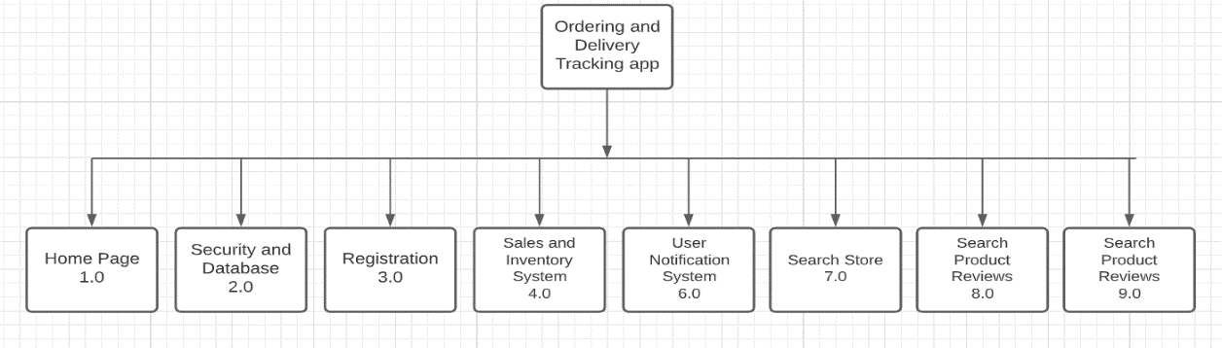

Figure 3.1 HIPO of the App

The app is composed of several components that would build the entire system. Each Customer, Store Owner, Rider, and Administrator app has each of the following of modules. Home Page, Security and Database, Registration, Sales and Inventory System (Store Owner), User Notification System, Search Engines and Full administrator tools. On the Figure above listed all the components for the customer’s app.

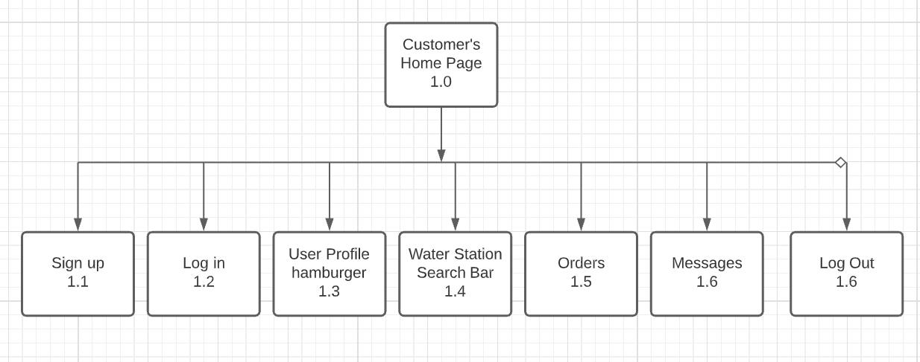

Figure 3.2 Customer’s Home Page

This is the sample HIPO of the Customer’s Home page is composed of useful and friendly UI for the customer. For the new customer they have to sign up, and that is where sign up button is for. Once profile has been created, he can log in in Log In button provided on the interface. Customers can also modify their profile information in User Profile hamburger tab, in this section they can modify or update their information that they used in signing up. One of the functions of this app is a feature of searching water stations and this is provided by the Water Station Search Bar, this can be found on the top of the screen. When they use the search bar the panel will provide them a UI or a Map for the location of the water station. They can tap on the icon and it will provide them an option to call or place an order with a User Interface tab. In Orders tab. Here customers can see their recent orders, they can also check the current status of the order and they have an option to cancel the order when they needed to. Messages tab is for notifications, this includes message order status and an order confirmation messages.

**System Architecture**

The proponents have identified what would be the best structure for the system. In this figure you can see the ideal system architecture, the system mainly has 4 types of users. Customers, Store Owner (Owner/Partners), Driver (Rider) and the Admin (Administrator/Developers)

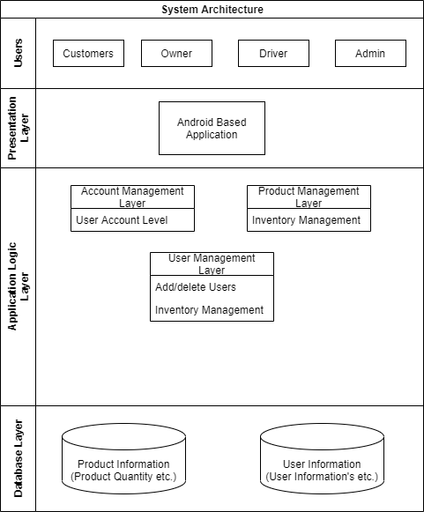

Figure 3.3 System Architecture of the System

All of the users will be using an android based application to their phones that can be connected through the internet, requests coming from the Users are being processed in application layers and servers. Since the server is Firebase the proponents would use its built-in cloud services like database. Authentication services and data and database management. The proponents will be using firebase plug-ins for the system.

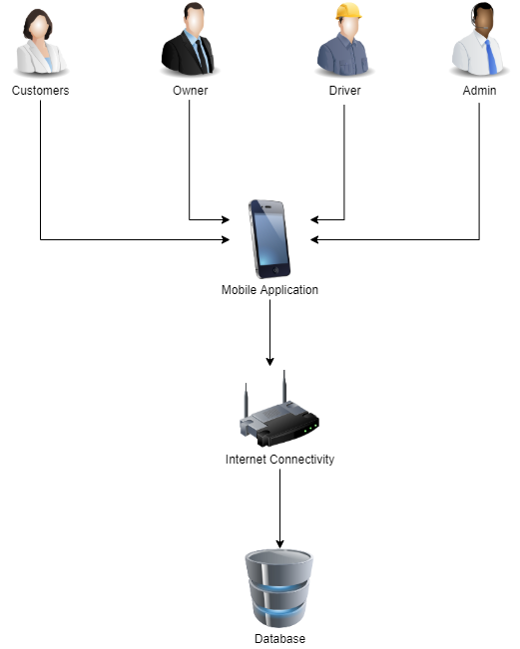

Figure 3.4 System Architecture for the System

**Conceptual Framework**

This section will represent the application as a conceptual entity-relationship model. The proponents defined conceptual design is required to discuss all needed data that acquired throughout the study and to prove that it supports all processes in the required specifications.

**OUTPUT**

Ordering and Delivery Tracker App for Quadro King Water Station Retail Store

**PROCESS**

Problem Definition

System Design

System Development

Testing

Evaluation

Implementation

**INPUT**

**Information & Knowledge Requirements**

* GPS
* Java/Kotlin
* Firebase

**Software Requirements**

* Android Studio

**Hardware Requirements**

* Device running Android marshmallow or above

Figure 3.5 Conceptual Design

We can see here in this section the technology used in the system. Android app development requires knowledge in the integration of Global Positioning System, the language for the system is written in either Kotlin or Java or can be both. The proponents used the most popular Interface Development Environment which is Android studio. The proponents strongly encourage to use this IDE in android development because it has lots of tools and sources available in the community and Stack Overflow.

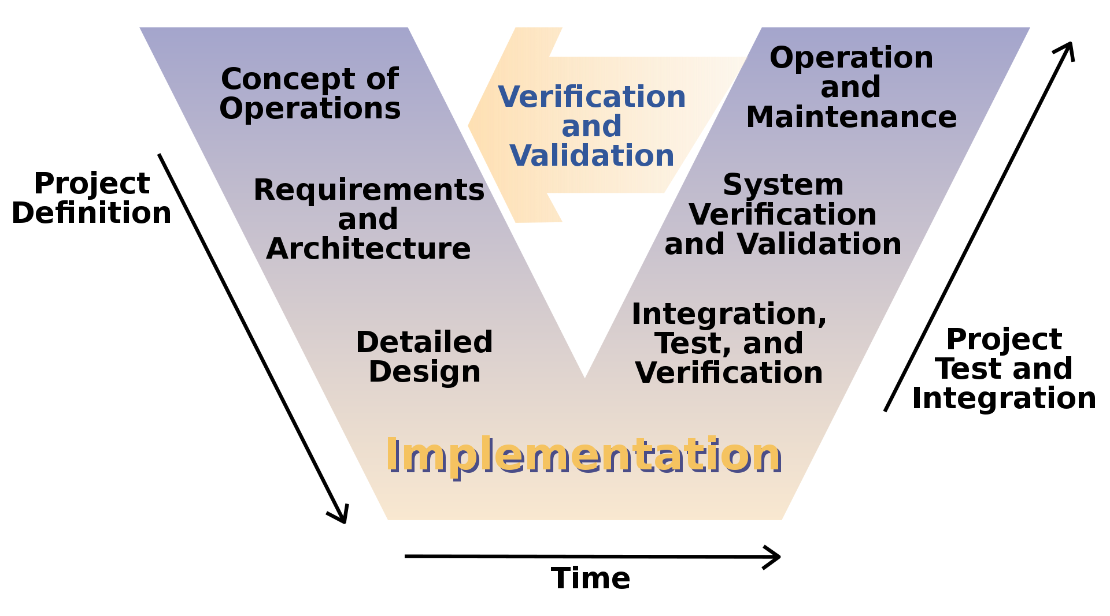

Figure 3.6 V-Model

In designing the project, we will undergo through phases of the study and will be represented in the V-model conceptual Design (Software Development). The early stages of the development should define the project and its goals for the users. In this part the proponents formulate the concept of Operations, the proponents should define what are the modules needed in order to construct the system. Concept of operations should be able to define the main goals of the software development, after that the proponents will be able to define what technology and design the architecture of the system, this will include the programming languages used, what systems services will be implemented and learn how to use them, integrate locations tracker (GPS) in the system since this is one of the main functions of the system. In Designing Phase, the proponents, after studying and gathering the requirements should be able to conceptualize the system design that would be the framework for all throughout of the system. The proponents will take advantage of designing and prototyping applications like Figma, and Adobe Suites. In designing the application, the proponents will have to make sure that the aesthetics are not being set aside. This is to make sure that the app will provide ease of use to the users without compromising the functionalities. After this phase, the proponents planned to implement the system in real world situation and would get feedback from the users about their overall application usage experiences. This will be gathered through a quick survey that is also integrated in the app’s feature. Upon gathering the data from the users, developers should check the integrity of the data and verify how will it provide a better design and functionalities. The developers shall conduct test tot define if the gathered data is contributing to the development of the system. Bugs, glitches and some software errors will be also be fixed once the integration test is done. System Verification and validation, in this phased the developers shall ensure that the fixes and modification they made in the app has been successfully integrated with the app after conducting series of test and will formulate plans to maintain procure additional system needs in the app. After the Project Test Integration Phase, the operation will cycle through the first phase which is the designing phase. This is how developers should be able to modify and make changes to the app with the consideration of all gathered information in Project Test Integration Phase.

**Cost Benefits Analysis (CBA)**

This section estimates the cost of the software, hardware and labor required by the application of the project. It should also demonstrate the values added to a given institution by the application of the project. The proposed application only needs a working android phone that has an android version of Kitkat or newer.

**I. Hardware Cost**

For the Rider:

|  |  |  |  |
| --- | --- | --- | --- |
| **Specifications** | **Quantity** | **Unit Price** | **Cost** |
| realme c11 | 1 | 4,990.00 | 4,990.00 |

**Total: 4,990.00**

**Table 3.1 Hardware Cost (Rider)**

Source: www.lazada.com.ph

|  |  |  |  |  |
| --- | --- | --- | --- | --- |
| **Recommended Requirements** | **Specifications** | **Quantity** | **Unit Price** | **Cost** |
| Processor | AMD Ryzen 3 2200G Processor | 1 | 5200.00 | 5200.00 |
| Motherboard | ASUS PRIME A320M-K | 1 | 2850 | 2850.00 |
| Ram | Kingston ValueRam 8Gb DDR4 | 1 | 2100.00 | 2100.00 |
| Hard Drive | Seagate BarraCuda 500GB | 1 | 1800.00 | 1800.00 |
| Monitor | PHILIPS 200V4QSBR LED 19.53-inches Full HD Monitor | 1 | 3300.00 | 3300.00 |
| Mouse / Keyboard | LOGITECH MK200 MEDIA USB KB AND MOUSE COMBO 800 | 1 | 800.00 | 800.00 |

**TOTAL:16,050.00**

Source: pcx.com.ph

**Table 3.2 Hardware Cost (Admin)**

**II. Software Development Cost**

|  |  |  |
| --- | --- | --- |
| **Personnel** | **No. of Personnel** | **Salary** |
| Programmer | 2 | 20,000.00 |
| System Analyst | 1 | 27,000.00 |

**Total:47,000**

**Table 3.3 Software Development Cost**

Source: www.jobstreet.com.ph

Personnel Salary for 60 days:

Programmer: 20,000 / 60 = PHP 333.33

System Analyst: 27,000 / 60 = PHP 450.00

**III. Operational Cost**

1. **System Cost**

|  |  |  |
| --- | --- | --- |
| **Items** | **Specification** | **Cost** |
| Front / Back End | Android Studio | Free |
| Database Hosting | Firebase | 533.65 / month (Small Level) |

**TOTAL:533.65 (MONTHLY)**

**Table 3.4 System Cost**

Source: www.firebase.google.com

1. **Utility Expenses**

|  |  |
| --- | --- |
| **Particulars** | **Cost** |
| Electricity | 6,000.00 |

**Total: 6,000.00**

**Table 3.5 Utility Expense**

Computer usage PHP 100 per day for 10 hours in 60 days

Source: www.meralco.com.ph

1. **Training Cost**

|  |  |  |  |  |
| --- | --- | --- | --- | --- |
| **Personnel** | **Amount per day** | **Days** | **Hours** | **Total** |
| Administrator | 180.00 | 3 | 3 | 540.00 |
| Employee | 180.00 | 3 | 3 | 540.00 |

**Total:1,080**

**Table 3.6 Training Cost**

(60 / hour * 3hours) * 3 days = PHP540.00

**IV. Summary Cost**

|  |  |
| --- | --- |
| **Cost** | **Amount** |
| Hardware Cost | 21,040 |
| Software Development Cost | 47,000 |
| System Cost | 533.65 |
| Utility Expense | 6,000 |
| Training Cost | 1,080 |

**TOTAL:** **75,653.65**

**Table 3.7 Summary Cost**

**Estimated Benefits:**

Accuracy and efficiency of the software at 85%

Total estimated benefits = 75,653.65* 85%

**Total = 64,305.60**

**Payback Period:**

Payback period = (Total Cost / Total estimated benefits) * 12

= (75,653.65/ 64,305.60) * 12

**Total = 14 months or 1 year and 2 months**

**Return of Investment:**

Return of investment = (Total estimated benefits / Total Cost) * 100

= (64,305.60/ 75,653.65) * 100

**Total = 85%**

**Requirements Analysis**

In this section, the proponents must determine information requirements with regard to the current working system when ordering water in the community. The system involves the consumers (customer who orders water), (Drinking Water Refilling Stations), Delivery Personnel (Rider/ The one who take the product to the customer’s location). The current system working in Metro Manila is where the customer calls or go to the shop to order the water container by providing the shopkeeper their address and then a delivery person delivers the order to the customer’s house. This current system has a lot of disadvantages. The major disadvantages of this offline system are repeated calls from the customer and to customer, if multiple orders are placed at the same area the delivery person has to travel multiple times, and there is no order tracing and there is a direct contact from delivery person to customer. Customers’ are also at risk of infection if they have to go outside of their homes to order water containers.

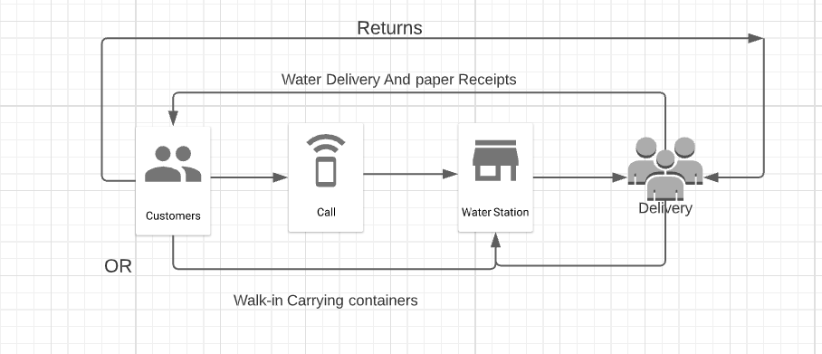

Figure 3.7 Current Water Ordering System

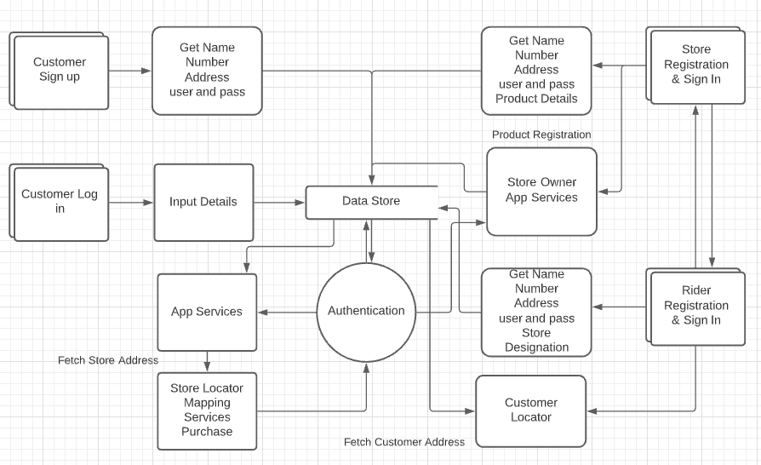

Figure 3.8 Dataflow Diagram of the proposed system

The Dataflow Diagram of the proposed system can be use to show more detailed view of the architecture of the processing system. This shows the design where the customer choose to sign in and use the app will ask for customer details such as Name, Address, user-id and password and it then send and store this to the database. Once done when they choose to log in into the App they have to input User-Id and Password details and will be authenticated through Firebase Authenticator, once security pass the customer can use the app services such as store locator where this will fetch information from the database and this will be authenticated. Store owners upon successful registration they can mange their products in the system they can either add product, modify and set price tags then this will be stored in the database this will also be showned if the customer wishes to purchases a product.

**System Flow**

System Flows are system models that shows the activities and decisions of the system when they are executed. This is useful for understanding complex system interactions because they visually show the back and forth interactions between systems and complex branching. These next figures will provide use a visual representation of the flow of the system, what are the branches provided when the specific decisions are made and shows what processes taken.

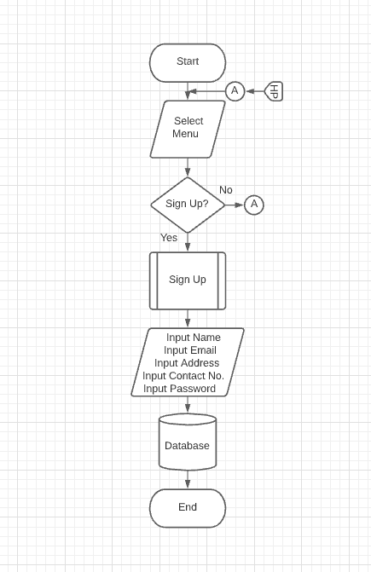

Figure 3.9 Customer Sign up

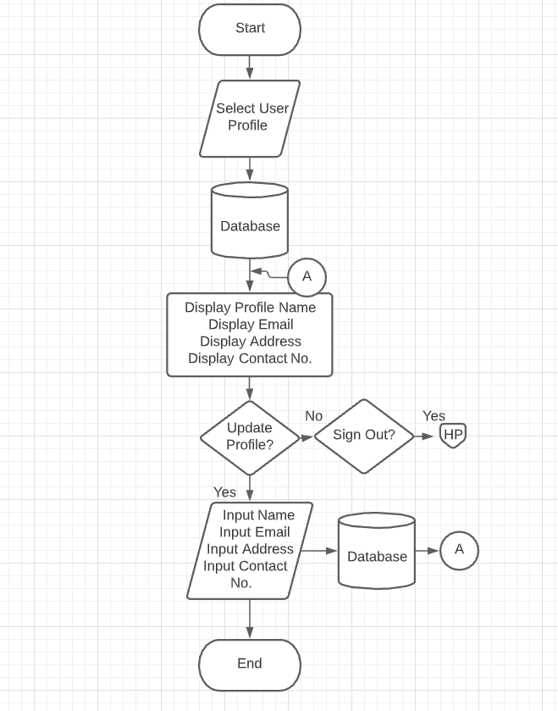

Figure 3.10 Customer Profile

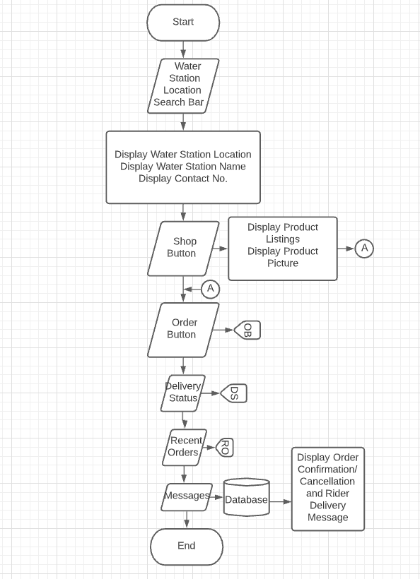

Figure 3.11 Water Station Search Bar

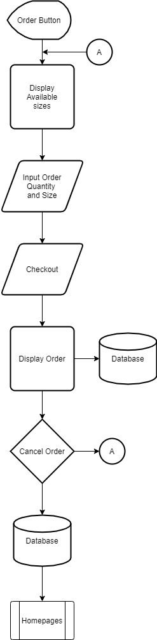

Figure 3.12 Order Button

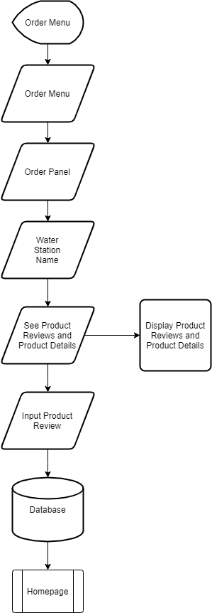

Figure 3.13 Order Menu

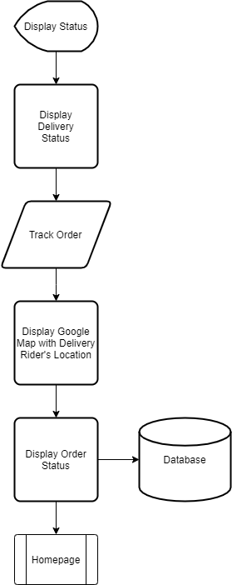

Figure 3.14 Order Status

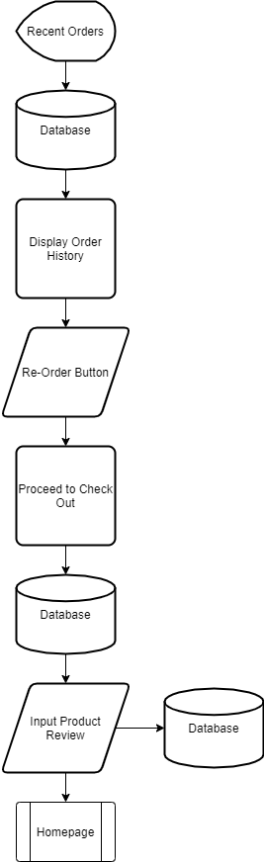

Figure 3.15 Recent Orders

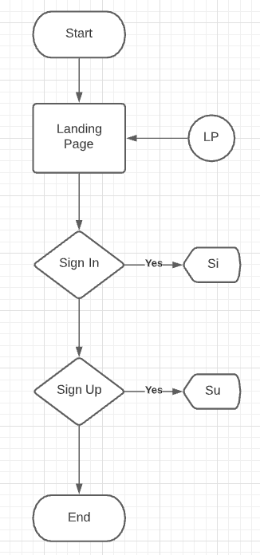

Figure 3.16 Driver App Flow

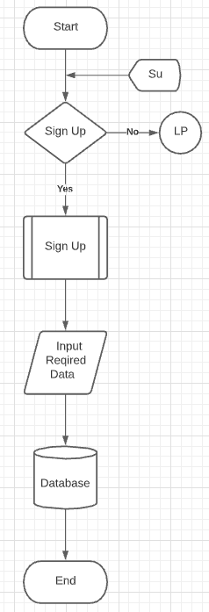

Figure 3.17 Rider Sign Up

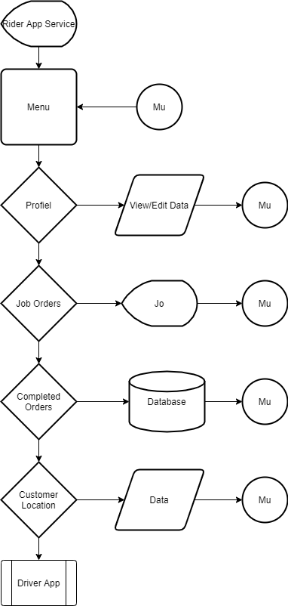

Figure 3.18 Rider App Services

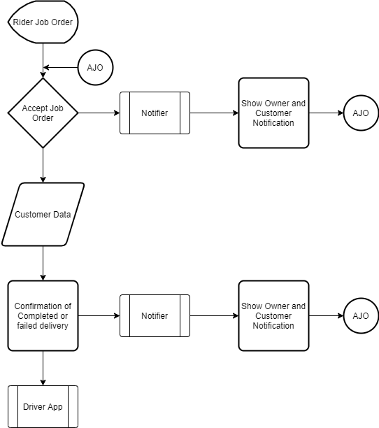

Figure 3.19 Rider’s Job Orders

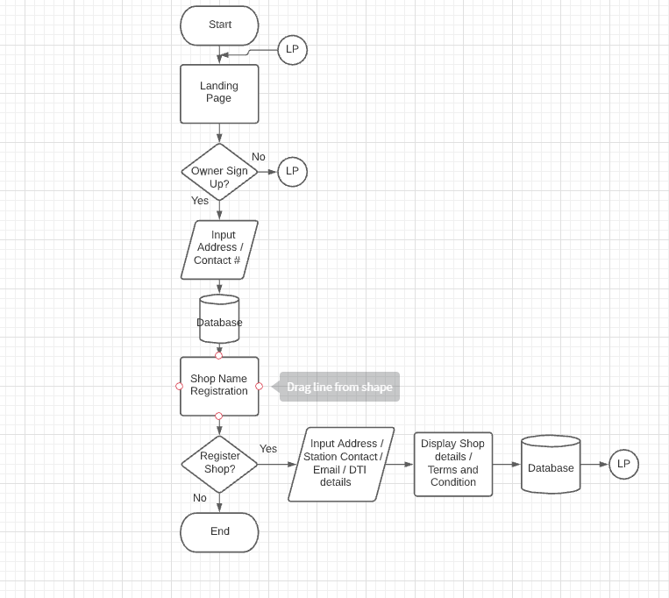

Figure 3.20 Store Owner registration

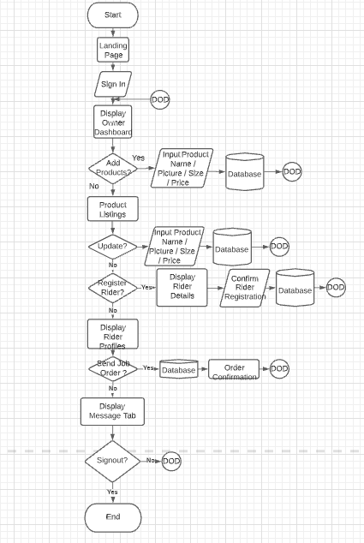

Figure 3.21 Store Owner Sign I

**Implementation Plan**

The developed system will be sent to Quadro King Water Station once the system is already approved by the adviser. If the company wants to apodt the proposed system, the proponents will hand over the system together with its documentation which will serve as a guide to the Administrator who will be assigned for the system’s update and maintenance.

|  |  |  |  |
| --- | --- | --- | --- |
| **Strategy** | **Activities** | **Persons Involved** | **Duration** |
| Approval from the company | Send letter to the company | Researchers  Admin | 1 Day |
| System’s Installation | Installation of the software to the computer | Researchers  Admin | 3-6 hours |
| Information distribution | Provide technical documentation | Researchers  Admin | 1 Day |
| 3 Days training | Hands on training for the employees | Researchers  Admin  Employees | 3 Days |

Table 3.7 Implementation Plan

**Input and Output Reports and Analysis**

This section will be represented by Input-Process-Output (IPO) diagrams. Identify all the modules based on your Hierarchical Input-Output (HIPO).The reference number will be based on the label number and indicated on your HIPO. Input are data, Process is an action world and Output will be the result of the action performed.

**Reference Number:**

**Module Name:** Login

**INPUT PROCESS OUTPUT**

**Reference Number:**

**Module Name:** Registration

**INPUT PROCESS OUTPUT**

**Reference Number:**

**Module Name:** Ordering

**INPUT PROCESS OUTPUT**

**Reference Number:**

**Module Name:** Input of Stocks

**INPUT PROCESS OUTPUT**

**Reference Number:**

**Module Name:** Check Out

**INPUT PROCESS OUTPUT**